 |  | 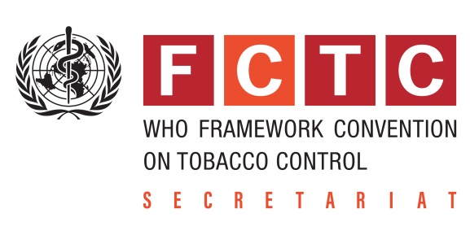

Visit of Dr Vera da Costa e Silva,
Head of the Convention Secretariat WHO FCTC
26 Feb – 1 Mar 2018
Version 0 (28 Jan 2018)
PROVISIONAL PROGRAMME

Monday, 26 February: Arrival to Tbilisi
18.30 | Flight from Amsterdam, Georgian Airways;  transfer secured by WHO CO OGEO
19.30 – 21.00 | Working (private) dinner, incl. initial briefing  Vera da Costa, Andrew Black, Marijan Ivanuša, Kakha Gvinianidze

Tuesday, 27 February
9.30 – 10.30  NCDC | Meeting with Dr. Amiran Gamkrelidze and NCDC tobacco control staff (topics to be discussed: current situation and progress in Georgia; FCTC 2030 strategy and action plan; communication campaign)  NCDC: Dr. Amiran Gamkrelidze  FCTC/WHO: Vera da Costa e Silva, Andrew Black, Marijan Ivanuša, Kakha Gvinianidze
11.15 – 12.00  Ministry of Labour, Health and Social Affairs | Meeting with Dr. David Sergeenko, Minister of Labour, Health and Social Affairs  FCTC/WHO: Vera da Costa, Andrew Black, Marijan Ivanuša, Kakha Gvinianidze
12.30 – 13.45 | Ad-hoc internal FCTC/WHO debriefing / working lunch  FCTC/WHO: Vera da Costa, Andrew Black, Marijan Ivanuša, Kakha Gvinianidze
14.15 – 14.45  Parliament of Georgia, Tbilisi | Meeting with Mr. Irakli Kobakhidze, Chairmen of the Parliament of Georgia  FCTC/WHO: Vera da Costa, Andrew Black, Marijan Ivanusa, Kakha Gvinianidze
15.30 – 17.00  NCDC | Launch of the FCTC 2030 project and Investment Case for Tobacco Control in Georgia  Vera da Costa, David Sergeenko, Min of Finance, Min of Economy, Akaki Zoidze, Amiran Gamkrelidze, Ambassador of UK in Georgia, Dudley Turlton (UNDP), WR, members of State Tobacco Control Commission and Health Promotion Council  Media  Detailed programme to be drafted by the NCDC and WHO CO GEO, incl. list of participants
19.00 – 21.00  Venue: tbd  Host: tbd  List fo guests: tbd | Official dinner  Provisional list of guests: David Sergeenko, Akaki Zoidze, Amiran Gamkrelidze, Giorgi Gakharia, etc.  UK ambassador  Vera da Costa, Andrew Black, Marijan Ivanuša, Kakha Gvinianidze

Wednesday, 28 February
10.00 – 10.30  Ministry of Internal Affairs | Meeting with Mr. Giorgi Gakharia, Minister of Internal Affairs  Vera Da Costa, Andrew Black, Marijan Ivanuša, Kakha Gvinianidze
11.00 – 11.45  Ministry of Finance | Meeting with Mr. Mamuka Bakhtadze, Minister of Finance  Vera Da Costa, Andrew Black, Marijan Ivanuša, Kakha Gvinianidze, Dudley Tarlton
12.30 – 13.30 | Private lunch
14.00 – 15.30  Parliament of Georgia, Tbilisi | Launch of the Smoke Free Communication Campaign  Detailed programme to be drafted by the State Tobacco Control Commission and Health Promotion and Prevention Council, NCDC and WHO CO GEO, incl. list of participants
16.30 – 17.00  WHO CO GEO | Meeting with Civil Society Organizations  NGOs: George Bakhturidze, Eka Lomidze, George Magradze  FCTC/WHO: Vera da Costa, Andrew Black, Marijan Ivanuša, Kakha Gvinianidze
18.00-20.30  tbd | Informal Dinner/debriefing  Vera da Costa; Andrew Black, Marijan Ivanuša, Kakha Gvinianidze

Thursday, 1 March
tbd | Departure: tbd;  transfer secured by WHO CO OGEO

